**Week 6 virtual work from home 4/27—5/1.**

* Zoom literature meeting: Wednesday, 4/29/20 at 2:45 pm with Mrs. Papenhausen and Mrs. White’s class.
* Zoom vocabulary fun: Friday, 5/1 at 1:30 pm.

**Weekly Lesson**

Novel Vocabulary - Please look at these new vocabulary words in the Quizlet link below and review the terms before you begin reading the weekly reading of our novel, “*Refugee.”*

Quizlet link: <https://quizlet.com/504575395/refugee-chapters-7-12-flash-cards/?i=ueb6o&x=1qqW>

**Class Challenge:** On Friday, at 1:30 pm, please log into our classroom and I will post a Zoom code to participate in a Zoom and a Gimkit competition with Mrs. White’s class. We will spend the first portion of the session on Gimkit and the 2nd portion will be to talk about the beginning reading for our novel ***Refugee***.

**NOVEL READING (Listening)**

**Due Thursday: Chapters 7-12 of “Refugee”**:

**Note about text:** This week we will be reading/listening to the next 6 chapters of the novel, each chapter is about 5-7 minutes each. You can break the reading into several different days, please don’t try to do them all at once, break them up by your class period schedule each day.

Google Slides Book Project- Please continue your slides for the book Refugee.

**Reading-Slide 5:  
Prediction**-As you read/listen to chapters 7-9 please write a prediction for each character. What do you think will happen to each character, and why/what makes you believe that?

1. Josef, on a train to Hamburg Germany, 1 day from home- page 34
2. Isabel, Just outside Havana Cuba 1994- page 40
3. Mahmoud, Aleppo Syria 2015- page 49

**Reading-Slide 6:**

**Inference**- As you read/listen to chapters 10-12, choose a question to focus on for each character (different question for each character), and infer what you believe is the reasoning to their actions. You will be answering three questions (a different one for Josef, Isabel and Mahmoud). You do not need “text” evidence if you are listening to the book, but you do need to remember to give a specific example on why you answered the way you did. RACE please.

1. Josef, somewhere on the Atlantic ocean, 6 days from home, 1939- page 56
2. Isabel, just outside Havana Cuba 1994- page 60
3. Mahmoud, just outside Aleppo Syria, 1 day from home, 2015- page 66

**Inference question options:**

•How do you think the characters treat each other?

•What can the character teach us and each other?

•How are the characters dealing with conflict?

•How do you see this character changing?

•What’s in this character’s heart?

•What motivates this character?

•Choose any other character in the story so far, and describe who they are revealing themselves to be?

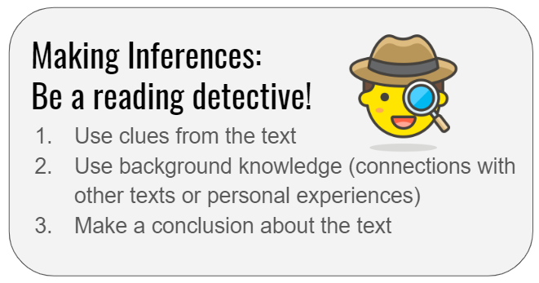

**Previous Slides:**

Slide 1: Cover slide, title it “REFUGEE” by Alan Gratz

Slide 2: Table of contents (keep track of slide numbers and the assignments on this slide

Slide 3: Task 1-Chapters 1-3 (Characterization)

Slide 4: Task 2-Chapters 4-6. (Conflict)

Slide 5: Task 3-Chapters 7-9 (Prediction of story line for each character: Josef, Isabel, Mahmoud).

**Missing Work**: Please remember to work on any missing work you have for our ELA class.  You can take pictures of your missing work and attach it to an email.  I will update the grade book as you turn in assignments. If you are missing a test in the gradebook, please email me and we will coordinate an assessment online for you to take.

Please email me with any questions. I will update our classroom again on Thursday of this week and will be available everyday this week as you need. Thanks!

Ms. Miles